Cancelled care research
July 2023
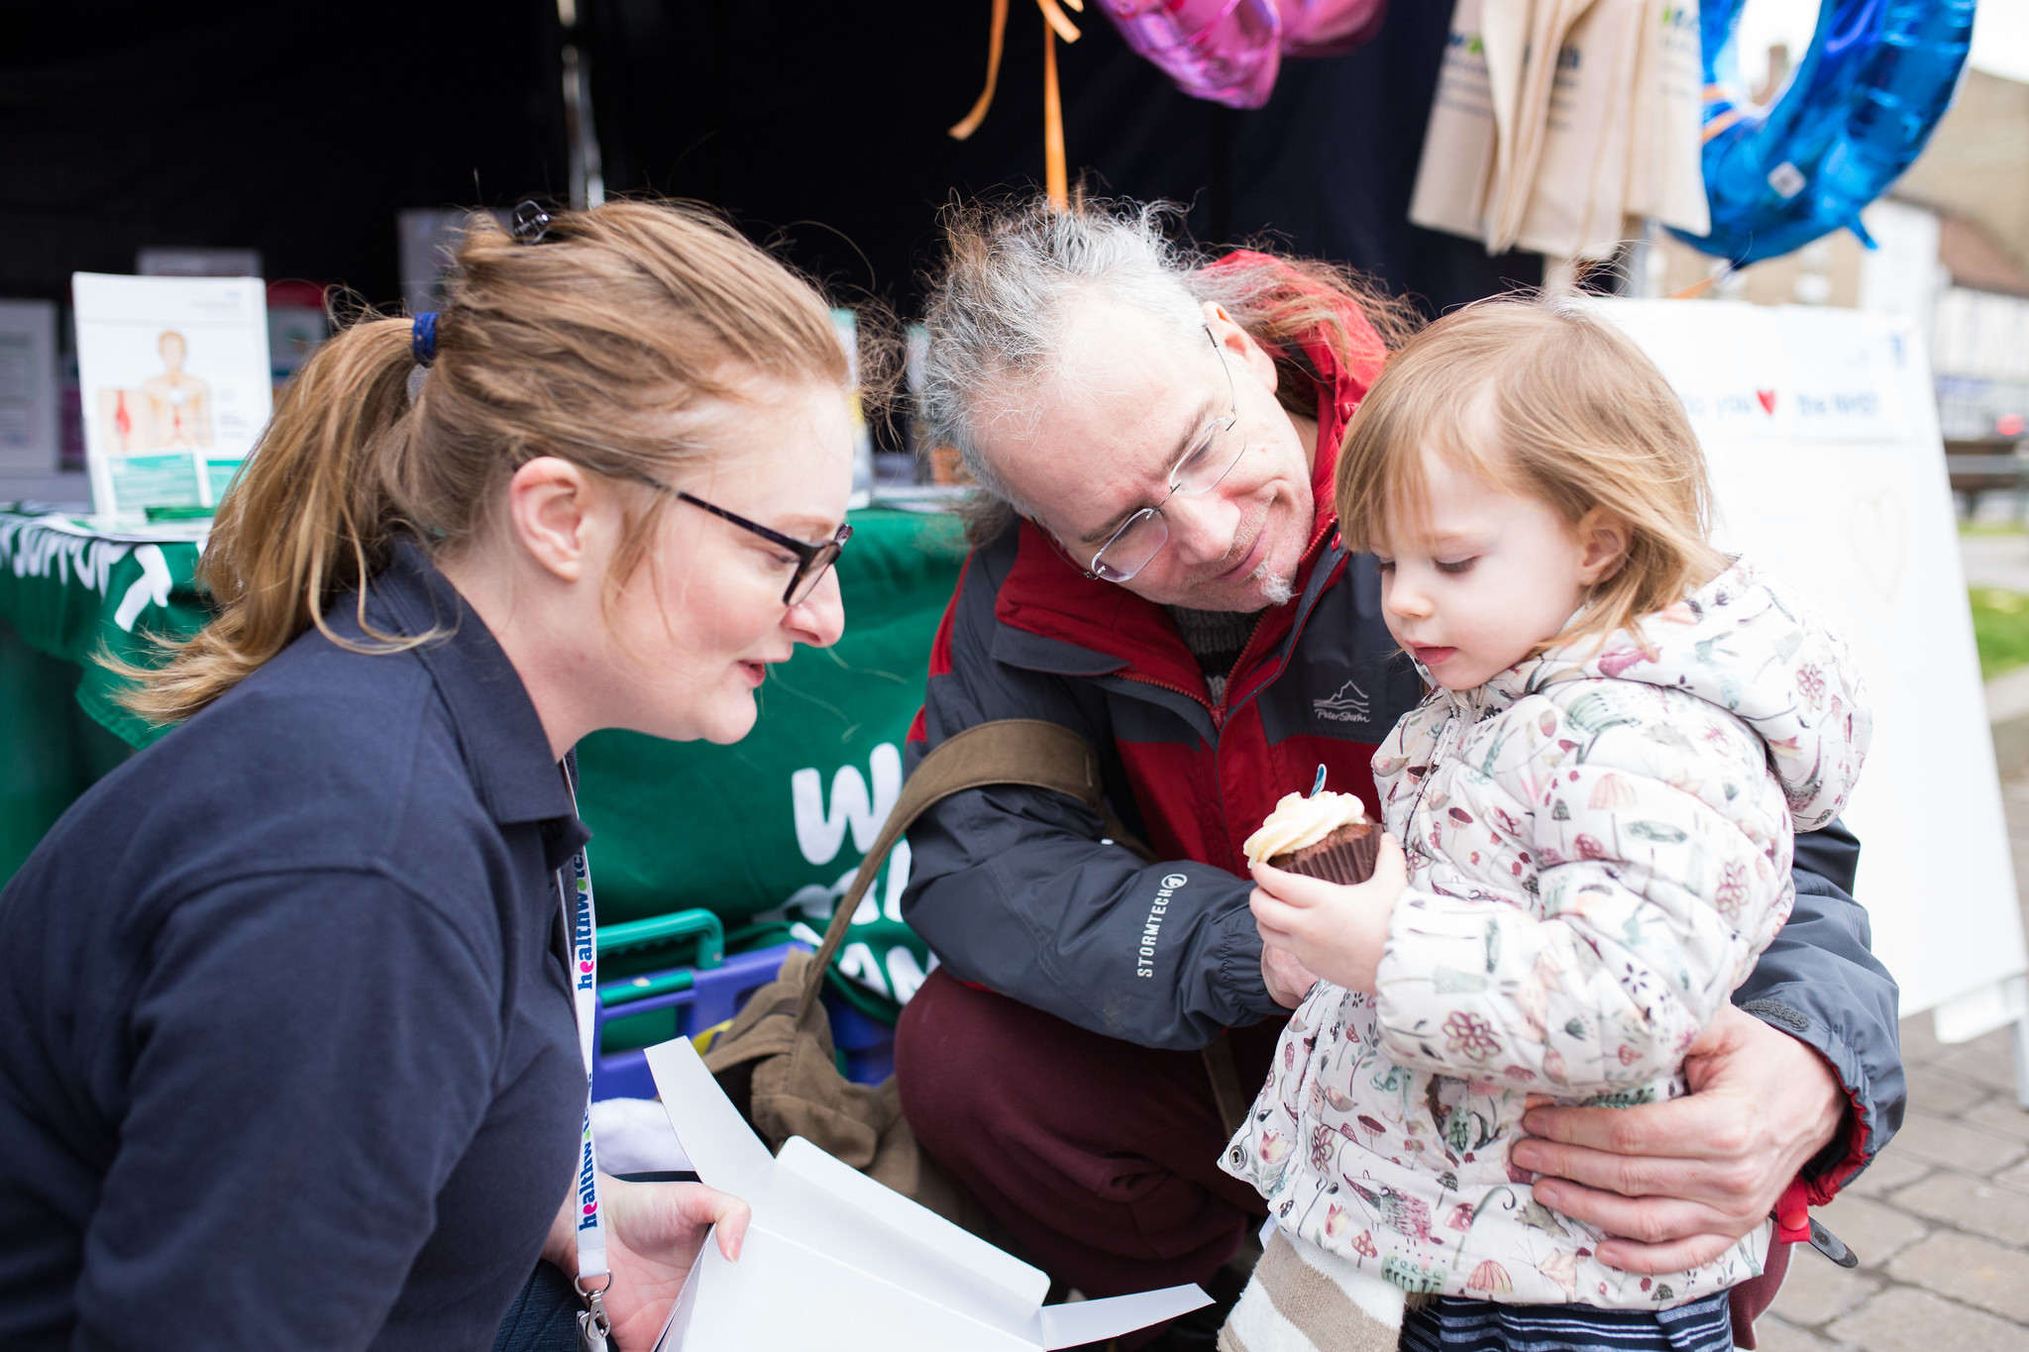

Contents

About the research………………………… ………...………… 3
Key findings 5
Findings: The cancellation experience 7
Two+ cancellation or postponements 8
Consequences of delay 9
Consequences for communities 11
Consequences for carers 12
Consequences of neurodivergent 13
Consequences by financial status 15
Consequences by ethnicity 17
Consequences of disabled people…………… 18
Consequences if you’ve a long-term condition 19
Information and support while waiting… 20
Reasons for cancelled care 21
Our calls for change 22
Appendix 1: what we asked… 33
Appendix 2: defining NHS patients 25
Appendix 3: Comparing samples 37
Appendix 4: Confidence intervals 28

About the research
We commissioned Yonder Data Solutions to run an online survey to learn about the impact of postponements and cancellations of recent or planned care or appointments in 2023.
This was against the context of the rising elective list, the ongoing impact of the pandemic and industrial action by NHS staff, and the proactive sharing of information by the public with the Healthwatch network about the impact of disrupted care caused by staff strikes.
Fieldwork was carried out between 26 June and 3 July 2023 in two phases:
- An initial survey of 1,038 people, nationally representative (NAT REP) by age, gender, region, social grade and ethnicity, to understand: how many were NHS users and, of those, how many had care cancelled in 2023.
Out of 1,038, 55% (568) confirmed they were an ‘NHS user’, which meant they either had an appointment for, had recently had an appointment for, or were on a waiting list for a diagnostic test/scan, operation/procedure, hospital outpatient appointment, or community hospital/service appointment. Of this group of 568 people, 141 people (25%, or 1 in 4) said they their care had been cancelled.
- To look beyond the topline statistics in the initial sample, Yonder continued with fieldwork to BOOST the number of respondents to reach a total sample of 1,084 people whose care had been cancelled or postponed in 2023.

Where different demographic groups are compared in the findings, e.g. carer versus non-carer, only those where significant differences (5% risk level) have been found, are displayed.

Key findings

- Initial research identified that 55% of a nationally representative sample of 1,038 people, in 2023, had used or were waiting to use NHS services (planned elective care, outpatient appointments and community health appointments).
- 25% of those NHS users had had their care cancelled.
- To look beyond those topline statistics, we boosted the research to reach a total sample of 1,084 people whose care had been cancelled in 2023, to find:
  - 39% had had their care cancelled on two or more occasions.
  - 18% said their care was cancelled at the last minute (on the day or upon arrival).
  - Certain groups were more likely to report that their care had been cancelled multiple times. These included disabled people, 52%; neurodivergent people, 51%; and people on lower incomes, ethnic minorities and LGBTQ+ being affected the most, 49% respectively.

Key findings (continued)

- 66% reported significant impacts on their lives due to the cancelled care, such as worsening mental health, ongoing pain and disrupted sleep.
- Certain groups were more likely to report these impacts. These included unpaid carers, 84%, and neurodivergent people, 83%; followed by people on low incomes, 80%; and those from minority ethnic backgrounds, 75%.
- 25% had not been given a new date for their care.
- 79% said they had been offered 'very little' or 'no' support to manage mental health needs during their new wait.
- 15% said the NHS told them their cancellation was due to strikes, 25% believed this was the reason, 41% said another reason and 20% didn't know why.

Findings: The cancellation experience

- 39% of the 1,084 people who had care cancelled, said this happened on two or more occasions.
- 45% said the cancellation happened between one and seven days beforehand.
- 18% had had their care cancelled at the last minute (on the day or on arrival at their appointment, to use the NHS definition of last-minute cancelled elective care).
- The following slide shows which groups experienced two or more cancellations, more than others.

Two+ cancellation or postponements
Boost sample
Those more likely* to have had two or more NHS postponement or cancellations are:
* Some people (e.g. disabled people) may be higher users of the NHS generally so maybe more likely to experience cancellation or postponement.
Consequences of delay
Boost sample
66% of those who’d had a cancellation or postponement for any reason, experienced consequences of some kind as a result.

What were the consequences of the POSTPONEMENT or CANCELLATION? | Count | % of NHS patients PP/Cancelled
It negatively impacted my mental health | 270 | 25%
I suffered on-going pain | 278 | 26%
My ability to sleep was affected | 203 | 19%
My condition/ symptoms got worse | 247 | 23%
It negatively impacted my physical fitness | 165 | 15%
It led to further problems/complications | 95 | 9%
It negatively impacted my ability to work (paid or voluntary) | 64 | 6%
I needed additional care from friends/ family | 61 | 6%
I experienced loss of income or increased costs | 93 | 9%
My ability to care for a loved one (e.g. child or elderly parent) was been affected | 55 | 5%
It negatively impacted my relationship | 54 | 5%
I needed social care support | 25 | 2%
There were no consequences | 364 | 34%
Something else | 35 | 3%
Don't know | 16 | 1%
Base: those experiencing postponement /cancellation | 1084 | 100%
Consequences | 720 | 66%

Base: 1,084 (have experienced a cancellation or postponement)
Consequences for communities
Boost sample
Those more likely to experience any consequences as a result of the NHS postponement or cancellations were:

Consequences for carers
Boost sample
Consequences of the NHS postponement or cancellations: Carer versus non-carer.

 | Carer | Non-carer
My ability to care for a loved one (e.g. child or elderly parent) was been affected | 21% | 2%
It led to further problems/complications | 17% | 7%
It negatively impacted my ability to work (paid or voluntary) | 9% | 5%
It negatively impacted my relationship | 10% | 4%
I needed additional care from friends/ family | 11% | 5%
I experienced loss of income or increased costs | 14% | 8%
When carers are impacted, so are the people they care for.
Base: not carer 923, carer 161
Consequences for neurodivergent
Boost sample
Consequences of the NHS postponement or cancellations: Neurodivergent versus not neurodivergent.
 | Neurodivergent | Not ND
My condition/ symptoms got worse | 37% | 22%
It led to further problems/complications | 16% | 8%
I suffered on-going pain | 40% | 24%
It negatively impacted my mental health | 52% | 23%
It negatively impacted my relationship | 11% | 4%
I needed additional care from friends/ family | 12% | 5%
I experienced loss of income or increased costs | 22% | 7%

Note: Neurodivergent people were more likely to be struggling financially and/or be LGBT+.
Neurodivergent people were more impacted overall than other groups and the heaviest impact was on their mental health.
*Caution as this was a small base – further research recommended for this group.
Base: not neurodiverse 1,001, neurodiverse 83* (small base)

Consequences by financial status
Boost sample
Consequences of the NHS postponement or cancellations: Financial status.
Those really struggling financially, also experienced high impact compared to other groups.
 | Financial situation
 | Very comfort-able | Quite comfort-able | Just getting by | Really struggling
My ability to sleep was affected | 8% | 17% | 18% | 34%
My condition/ symptoms got worse | 14% | 20% | 22% | 41%
It led to further problems | 8% | 7% | 9% | 17%
I suffered on-going pain | 12% | 24% | 27% | 37%
It negatively impacted my physical fitness | 8% | 15% | 16% | 19%
It negatively impacted my mental health | 8% | 19% | 29% | 44%
I experienced loss of income or increased costs | 9% | 7% | 8% | 15%

Base: very comfortable 85* (small base), quite comfortable 437, just getting by 440, really struggling 116
Consequences by ethnicity
Boost sample
Consequences of the NHS postponement or cancellations: Ethnicity.
Impacts more on life factors.
Base: white 804, non-white 280
Consequences for disabled people
Boost sample
Consequences of the NHS postponement or cancellations: Disabled versus not disabled.
Base: Not disabled 868, disabled 216
Consequences if you have a long-term condition
Boost sample
Consequences of the NHS postponement or cancellations: Long-term condition versus no long-term condition.
Base: no long-term condition 694, long-term condition 390
Impacts more on their physical and mental wellbeing.
Information and support while waiting

- 24% of the 1,084 people whose care had been cancelled, had not been given a new appointment or procedure date and of this group, 82% said the NHS hadn't told them when they would receive a date.
- 79% said they had been offered 'very little' or 'no support' by the NHS to manage mental health needs during their wait.
- 52% said they had not been offered support by the NHS to manage their medical symptoms during their wait.
- 24% said they had a 'a lot of support' during their wait to manage needs.
- 21% said they had received 'a little support'.

Reasons for cancelled care
Boost sample

- 15% of 1,084 people said the NHS told them that their cancellation was due to strike action.
- A further 24% of people thought strike action was the reason.
- 41% said the cancellation was for another reason.
- 20% didn't know why.

Our calls for change
NHS England, Integrated Care Boards and NHS providers should do more to:
Appendix 1: what we asked
- Which of these NHS services have you (a) recently had in 2023, (b) currently have a scheduled appointment for or (c) are on a waiting list for.
- Have any of the NHS services you've had or are due to have, been CANCELLED or POSTPONED in 2023?
- How many times was the NHS service you've had or are due to have been CANCELLED or POSTPONED?
- How much notice were you given that your NHS service was being CANCELLED or POSTPONED? (If there is more than one, please consider the most important one to you)
- Did the NHS strikes have anything to do with the POSTPONEMENT or CANCELLATON of your NHS service?
- What were the consequences of the POSTPONEMENT or CANCELLATION?
- Were you given a new date?
- Has the NHS kept you informed about when you're likely to get a new date?
- What level of support were you given to help manage your medical condition while you were waiting (or are currently waiting) for your appointment?
- What level of support were you given to help with your mental wellbeing while you were waiting (or are currently waiting) for your appointment?

Appendix 2: defining NHS patients
Q9. Which of these NHS services have you (a) recently had in 2023, (b) currently have a scheduled appointment for or (c) are on a waiting list for.

Those ticking any of the relevant boxes were considered users of NHS services in 2023 and potentially affected by the strikes. 55% of the nat rep sample fall into this category.

 | (a)  I have recently (2023) had an NHS... | (b)  I have an NHS appointment scheduled for... | (c)  I am on an NHS waiting list for...
Diagnostic test/ scan | 21% | 9% | 5%
Operation/ procedure | 6% | 3% | 7%
Hospital outpatient appointment | 25% | 19% | 7%
Community hospital/ service appointment | 9% | 5% | 1%
Not applicable | 55% | 68% | 82%
Base | 1038 | 1038 | 1038
Applicable | 45% | 32% | 18%

Appendix 3: Comparing samples
We used screening questions to reach the relevant people in the NAT REP sample who have experienced cancellation or postponement in 2023.
 | Nat rep | Boost
Total respondents | 1038 | 1084
Used/using/waiting to use NHS services in 2023 (NHS patients): | 568 | 1038
NHS services you've had or are due to have, been CANCELLED or POSTPONED in 2023? | 141 | 1084
In order to look beyond the topline statistics in the NAT REP sample, we continued with fieldwork to BOOST the number of respondents who experienced cancellation or postponement to over 1,000 – allowing meaningful comparison between different demographics. We also attempted to include greater numbers of ethnic minority and lower financial status respondents.
Appendix 4: Confidence intervals
We can use Confidence intervals to help express how reliable a sample is with respect to the data we measure from it. Confidence intervals are a range, between which we can be 95% (typically) sure that the true population mean lies.
Confidence Interval for different values | Survey measure
Survey percentage | 10% | 30% | 50% | 70% | 90%
95% Confidence Interval for sample of 1,000 | +/- 1.9% | +/- 2.8% | +/- 3.1% | +/- 2.8% | +/- 1.9%

For more information
Healthwatch England
National Customer Service Centre
Citygate
Gallowgate
Newcastle upon Tyne
NE1 4PA
www.healthwatch.co.uk
t: 03000 683 000
e: enquiries@healthwatch.co.uk
@HealthwatchE
Facebook.com/HealthwatchE

