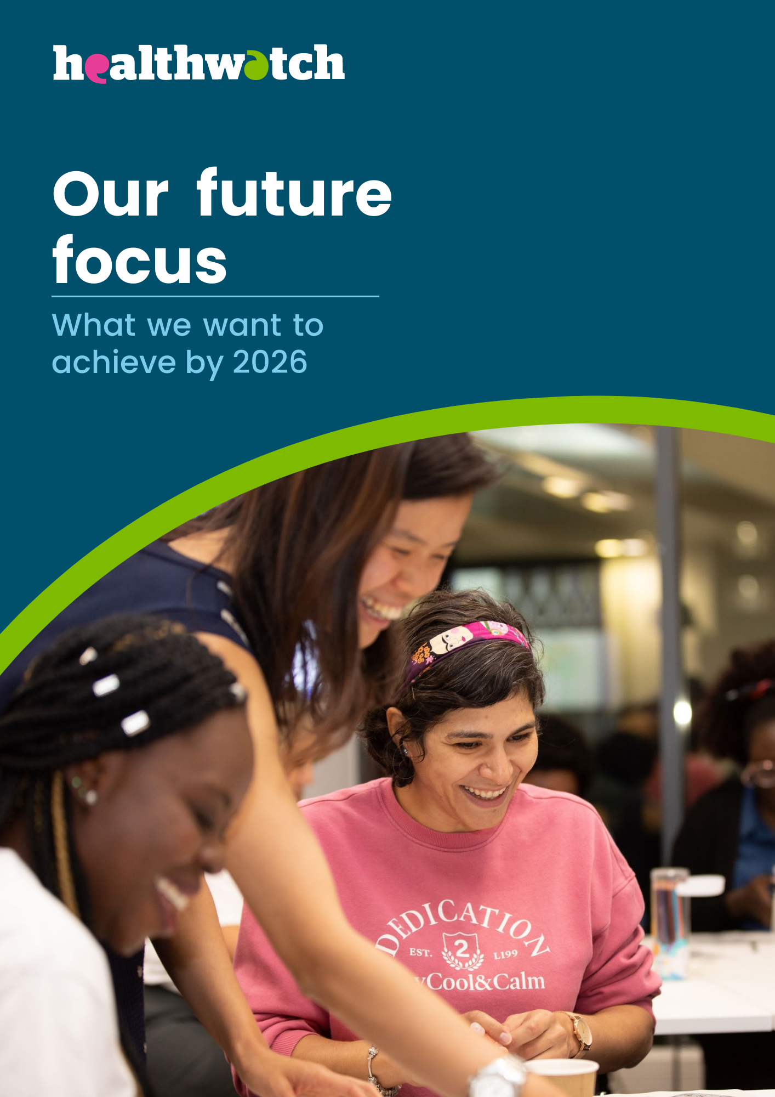

Contents
About us 3
An introduction 6
A changing world 11
Our aims 15
What would success look like 26
Thank you 27

About us

Our vision, mission and values
If you use health services or need care, we want to hear about your experience.
We have the power to make sure NHS and social care leaders listen to your feedback and improve standards of care. We can also help you to find reliable and trustworthy information and advice.
Wherever you live in England, you’ll also have a local Healthwatch nearby. Last year, we helped two million people to have a say and get the support they need.

Our vision
To bring closer the day when everyone gets the care they need.

Our mission
To make sure that people’s experiences help make health and care better.

Our aims
- To support more people who face the worst outcomes to speak up about their health and social care, and to access the advice they need.

- To support care decision-makers to act on public feedback and involve communities in decisions that affect them.

- To be a more effective organisation and build a stronger Healthwatch movement.

Our values
- Listening to people and making sure their voices are heard.

- Including everyone in the conversation – especially those who don’t always have their voice heard.

- Analysing different people’s experiences to learn how to improve care.

- Acting on feedback and driving change.

- Partnering with care providers, Government, and the voluntary sector – serving as the public’s independent advocate.

Our committee
The Healthwatch England Committee is a statutory committee of the Care Quality Commission (CQC). Our main functions are to:
- Provide leadership, guidance, support to local Healthwatch;

- Escalate concerns about health and social care services to CQC;

- Advise Government, NHS England and local authorities about the quality of services; and

- Set our strategy, provide scrutiny and oversight, and approve the policies we need to work effectively.

As public servants, we are committed to being open, accountable, selfless, objective, honest and displaying leadership as set out in the seven Nolan Principles of Public Life.

An introduction

Responding to uncertain times

Listening is more important than ever

Seventy-five years after its birth, the NHS and the social care system faces enormous challenges and big questions about how we invest in future services. How can services:
- Refocus on prevention to help us all live healthier for longer and address the challenges of our ageing population?

- Help address the deep inequalities, which see factors like where you live, ethnicity or gender result in different health outcomes?

- Work together to provide better, more joined-up, efficient care?

- Meet the increasing demand for mental health support and work with others to improve wellbeing?

- Harness technology and information to improve communication and give more control to patients, service users and carers?

Highlight health inequalities.
We face unfair and avoidable differences in health across the population and between different groups in society, but the picture can be complex and mixed.

Life expectancy: People living in England’s most deprived areas of England live 7.9 fewer years than those living in the least deprived areas.

Physical health: People in the most deprived areas of England are 4 x more likely to die early from cardiovascular disease.

Mental health: Mental health detentions in the most deprived areas are 3.5 x higher than the rate of detention in the least deprived areas.

Tackling the care backlog and building a future service that can help people stay well and support those in need will be challenging. Health and social care decisionmakers need the public’s input. And this is where Healthwatch comes in.

Building on ten years of Healthwatch

We’ve demonstrated the power of public feedback to help services understand what’s working, spot issues and d think about how care can be better.

But with the NHS and social care services facing such serious problems, we must consider how Healthwatch staff and volunteers across England can continue to hold decision-makers to account and make an even bigger difference.

With funding in the Healthwatch network just 49% of what was initially allocated and public finance likely to be constrained for the foreseeable future, it will take hard work and imagination to ensure we maximise our impact.

After extensive engagement with staff, stakeholders, and the public, we believe that we need to:
- Continue to raise our profile so every community knows we are here for them.

- Focus on the big issues that most concern the public and the communities that face the worst health inequalities.
- Work with the NHS at every level – locally, regionally, and nationally – to find solutions and make listening to service users the default approach across all health and care.

- Harness the resources of the Healthwatch network more efficiently and put our funding on a sustainable footing.

Three big uses people want us to work on where we aim to support major improvement:
- People’s experience of GPs, dentists and other primary care services because it is the number one thing people talk to us about.

- Social care because it is a significant area of care people tell us needs fixing.

- Women’s health because women wait longer for care and have poorer experiences.

The difference we made in just one year.
Six ways people’s feedback helped us make a difference in 2021-22:
- Healthwatch research exploring vaccine confidence with people from different backgrounds provided vital lessons for public health campaigns.

- Public feedback helped highlight the negative impact poor NHS admin can have and recommended five principles for services to improve people’s experience.

- The Government updated national hospital discharge guidance to put patient safety first, thanks to the views of patients and carers.

- NHS England announced improvements to non-emergency patient transport services thanks to public feedback.

- Healthwatch uncovered that only a third of NHS Trusts fully comply with their duty to help patients with sensory impairments and learning disabilities, which has helped lead to a national review of the Accessible Information Standard.

- We continued to voice public concerns that improvements to NHS dentistry are too slow, leaving thousands of people in pain.

A changing world

The opportunities and challenges to make care better

Looking out – the external factors we need to consider

Challenges:
- High demand for health and social care support and widening inequalities.

- Environmental change causing health insecurity.

- Public funding for health and social care and for patient involvement is restricted.

- Not enough health and care staff and support services in the community.

- Falling public trust and confidence in NHS services.

Opportunities:
- Using technology to deliver personalised, efficient care.

- Focus on preventing illness and boosting people’s wellbeing.

- NHS reforming to provide more joined-up care.

- Increase in community-led action to improve health and social care.

- A greater consensus that involving people in health and social care improves outcomes.

Looking in – taking stock of our strengths and weaknesses

Strengths:

- We have a broad remit that covers all NHS and social care services.

- We’re present in every area, with links to every community.

- Our statutory role gives us a seat at the table.

- More people know who we are and use us.

- An increasing number of health and social care decision-makers value us.

- Our people are skilled and committed.

- We have strong partnerships which continue to amplify our influence.

- The quality of our systems, service and insight is better than ever.

- We’ve shown the difference listening makes in improving people’s experience of care.

Where we can improve:

- Hearing more from those facing the greatest health inequalities.

- Filling the geographical and demographic gaps in our data.

- Ensuring listening to people is central to the culture of health and care services.
- Turning more of those who use our service into advocates.

- Ensuring more of our recommendations are acted upon by health and care services.

- Building a more diverse Healthwatch team that reflects all the communities we serve.

- Working with a wider range of organisations to reach new people and get new perspectives.

- Making our systems, support, and funding model sustainable.

- Demonstrating that listening saves money and improves health and social care outcomes.

Our aims
Do more to tackle inequalities, have a greater impact and be more effective
1. To support more people who face the worst outcomes to speak up about their health and social care, and to access the advice they need.
Where are we now
More people use our service, are aware of us and would recommend us. But reaching people, especially those facing inequalities, is getting harder, and confidence that services will improve is falling. We don’t make every contact count by retaining the support of those who use us, involving them in our work and telling them the difference they’ve made.

Lucy’s view: The cost of living is affecting peoples physical and mental health.
Single mum Lucy, from Cheshire, had to leave work to manage her MS and bipolar disorder. Because of her illness, she needs to pay for extra help around the house, and her symptoms get worse during winter.

“The weather affects my MS a lot so I’m buying extra things to stay warm,” she explains. “Then I have to have more showers to help with the pain, so I spend more money on electricity and gas.”

The rising costs aren’t just putting a strain on Lucy’s finances. As a result, her mental health and general wellbeing are also taking a hit:

“I’ve tried to cut down on food and heating to save money,” she explains. “But the cold causes me a lot of pain. And I have a child so it’s very hard. I have had to use the foodbank several times this year. “I don’t have money left over after paying bills now, so I don’t get to do anything with my daughter. It makes me feel like a failure.”

Our Goal by 2026:
At least half of the public are aware of us, and we have a powerful supporter base, representing every community, who share feedback, get involved in our work and know the difference their views have made.

Where we want public awareness of Healthwatch to get to:
- 2015 – 24%

- 2023 – 39%

- 2026 – 50%

The challenges we face:

Keeping pace with changing communications channels and ensuring we have the content, systems, and resources to maintain awareness and retain support.

The steps we will take:
- We will focus on the issues that most matter to people, such as access to primary care and social care and the support women need for their mental and physical health.

- We will campaign to boost our profile in communities facing health inequalities, such as those living in areas of high deprivation or those from ethnic minority backgrounds.
- We will strengthen our Healthwatch network-wide approach to content, brand and marketing.

- We will develop an approach to engage and build our supporter base and involve them in shaping our work.

- All of our research projects will have an aim to reduce inequalities for a section of the population who suffer the worst health outcomes.

Signs of success:
- At least 50% of the public will be aware of us.

- Over 200,000 people will have signed up to find out more about us and to get involved in our work.

2. To support care decision-makers to act on public feedback and involve communities in decisions that affect them.
Where are we now.
Care decision-makers increasingly know who we are and use the evidence we produce. Our impact and influence are growing. But we have gaps in our data, especially for those facing inequalities. We need people to be listened to at every level of the health and social care system, but some professionals still question the value of our insight.

Our Goal by 2026:
Our evidence, especially regarding health inequalities, is more valued than ever. The voice of people is better represented locally, regionally, and nationally within health and social care.

Amanda’s view: Why people’s experiences can help make care better.
“By working in close partnership with the Healthwatch network to understand patient experience, we support people to get the help they need, in a way that works for them.
“Using patient feedback effectively is essential to continuous improvement in the NHS with insights used to tailor services that meet people’s needs now and into the future. It also underpins partnership working between the service, patients and the public that helps keep the NHS efficient and best value for the taxpayer.
“We look forward to working closely together with Healthwatch as part of our shared role to secure the best possible health outcomes for patients, carers, families and communities.”
- Amanda Pritchard, Chief Executive, NHS England

Where we want public awareness of Healthwatch to get to:
The most significant barriers that stopped people from sharing feedback on health and social
care services:
- 20% Worried that it could negatively
impact on my care

- 20% Worried that will cause problems for health and care workers

- 18% Don’t know how to feedback on care

- 17% Don’t think people will listen to my feedback

The challenges we face:
Ensuring that our evidence is consistent, based on the best methodologies and accessible to a health and social care system that is willing to listen.

The steps we will take:

We will establish a robust evidence framework that articulates our distinct approach to gathering and analysing user stories, strengthening its perceived validity in systems that still largely favour statistical analysis over lived experience.

We will work with partners, like the Care Quality Commission, to pool insight, develop solutions and demonstrate impact.

We will campaign for a stronger culture of listening to and acting on feedback and do more to support professionals to involve people in shaping their care.

Signs of success:
- 85% of our health and care decision makers will value our evidence and insight.

3. To be a more effective organisation and build a stronger Healthwatch movement.

Where are we now.

We know what a high-quality Healthwatch service looks like and the core skills our people need. We’ve got better systems and support, and we have established the values the Healthwatch network shares. But funding for Healthwatch is under pressure, our systems aren’t universally used, quality is threatened by churn in local Healthwatch staff and providers, and the Healthwatch workforce could be more diverse.

Our Goal by 2026:
We have the funding, culture, skills, and infrastructure we need to be our best.

Baz’s view: Why our support matters to local Healthwatch
“The support that the team at Healthwatch England provide is invaluable.
“Whether offering training to help my staff support our community, helping us to demonstrate our
impact or putting the issues people tell us about on the national agenda, their help makes a real difference.
“However, with money for our service under pressure nationally, the renewed focus on making funding more sustainable for our vital work is really welcome.”
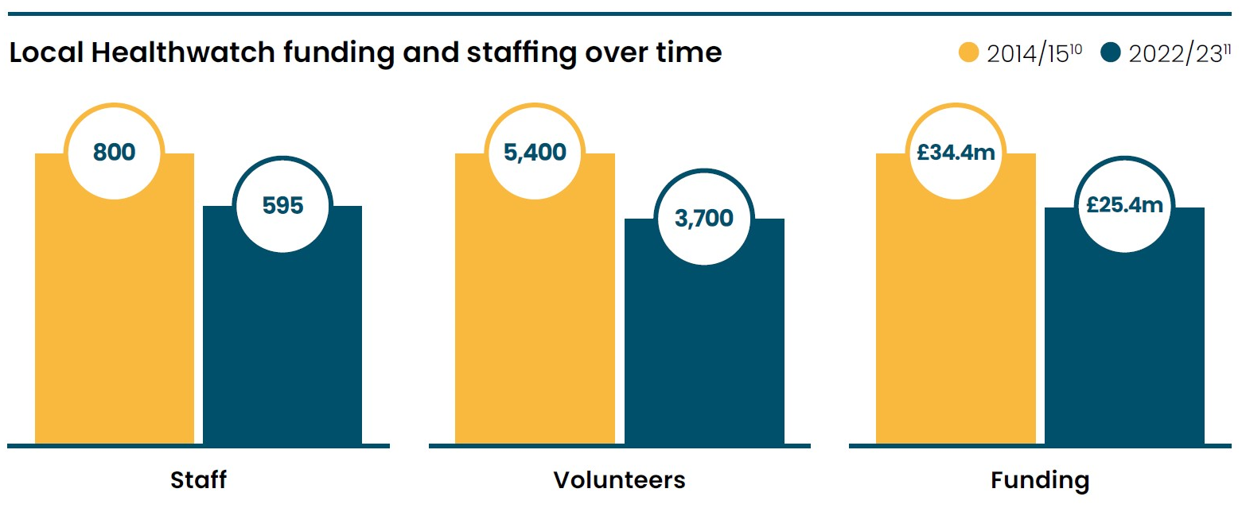
- Baz Tameez, Manager, Healthwatch Staffordshire
Local Healthwatch funding and staffing over time:
2014/2015:
- Staff – 800

- Volunteers – 5,400

- Funding - £34.4m

2022/2023:
- Staff – 595

- Volunteers – 3,700

- Funding - £25.4m

The challenges we face:
Meeting demand and maintaining quality when funding is falling, retaining staff is harder and local authority contracts for local Healthwatch services are often short-term.

The steps we will take:
- We will support staff across the network to master the core skills they need and build communities of practice.

- We will renew our culture and governance.

- We will invest in the right data and technology.

- We will explore new ways of commissioning local Healthwatch to establish a more sustainable funding model.

- We will improve impact and efficiency by refreshing processes & approaches to collaboration.

Signs of success:
- 90% of Healthwatch staff will highly rate the training and support we provide.

- A more sustainable funding model for the Healthwatch network is in place.

Knowing we have arrived
What would success look like in 2026?

Public:

More people than ever know who we are and how we can help.

We have a powerful supporter base, representing every community, who share feedback, get involved in our work and know the difference their views have made.

Health and care professionals:
- The voice of people is heard at every level of health and social care.

- The strength of our evidence, especially when it comes to health inequalities, is acted on more than ever to provide better care.

Our people:
- We have the funding, culture, skills and infrastructure we need to be our best.

The day when everyone gets the care they need is a step closer.
Thank you
We’re grateful to everyone who helped shape this document by sharing their thoughts, ideas, and reflections.

A special mention to:
- The patients and services users who gave up their time to take part in our focus groups.

- Our staff and committee for their months of hard work and commitment.

- Our NHS, social care and third sector partners who were kind enough to share their reflections.

- The local Healthwatch staff who helped shape our plans, especially the members of our Strategy Reference Group.

References
1. Seven Principles of Public Life, Committee on Standards in Public Life, May 1995.

2. Health state life expectancies by national deprivation deciles, England: 2018 to 2020, ONS, April 2022.

3. Health Inequalities Dashboard: statistical commentary, Office for Health Improvement and Disparities, June 2022.

4. Mental Health Act Statistics, Annual Figures, 2021-22, NHS Digital, October 2022

5. Local Healthwatch funding 2022-23, Healthwatch England, March 2023.

6. Annual Report to Parliament 2021-22, Healthwatch England, March 2023.
7. Public confidence in Government stewardship of NHS falls to new low, poll finds. BMJ, February 2023.

8. Polling conducted with a representative sample of 1000 adults in England, Healthwatch England, January 2015 and 2023.

9. Polling conducted with a representative sample of 1000 adults in England, One Poll, December 2022.

10. Annual Report to Parliament 2014-15, Healthwatch England, October 2015.

11. Annual Report to Parliament 2021-22, Healthwatch England, March 2023.

Seven Principles of Public Life, Committee on Standards in Public Life, May 1995.
Health state life expectancies by national deprivation deciles, England: 2018 to 2020, ONS, April 2022.
Health Inequalities Dashboard: statistical commentary, Office for Health Improvement and Disparities, June 2022.
Mental Health Act Statistics, Annual Figures, 2021-22, NHS Digital, October 2022
Local Healthwatch funding 2022-23, Healthwatch England, March 2023.
Annual Report to Parliament 2021-22, Healthwatch England, March 2023.
Public confidence in Government stewardship of NHS falls to new low, poll finds. BMJ, February 2023.
Polling conducted with a representative sample of 1000 adults in England, Healthwatch England, January 2015 and 2023
Polling conducted with a representative sample of 1000 adults in England, One Poll, December 2022.
Annual Report to Parliament 2014-15, Healthwatch England, October 2015.
Annual Report to Parliament 2021-22, Healthwatch England, March 2023.

