Our strategy explained

2021-2026
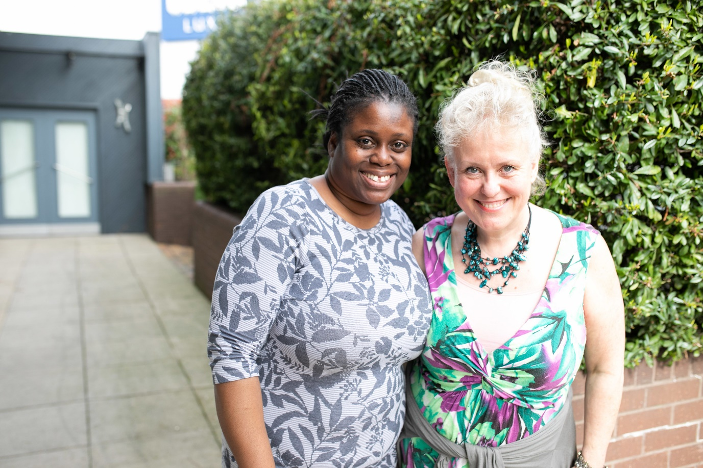
2021 - 2026

Introduction

The journey so far
Our strategy developed in 2018 set out three ambitious goals to ensure health and care works for everyone, and that our work is guided by those we serve. Our goals were to:
- Support more people to have their say and provide clear information and advice to help them take control of their health and care.
- Provide an effective, high-quality local service, building our network’s skills to achieve change together.
- Work together with professionals, providing useful insight to improve the planning, delivery and support of health and social care.
For the past three years these goals have guided us to achieve tremendous milestones. For example, last year alone Healthwatch helped nearly a million people find critical advice and information. We also supported 350,000 people to share their NHS and social care experiences, enabling us to make recommendations to services about improvements.

Our next steps
With the nation, particularly NHS and social care services, facing significant challenges, Healthwatch’s role is crucial. To ensure we are as effective as possible and that our work continues to have the greatest impact, we have refreshed our strategy.
Whilst we will continue to support people to have their say, provide a high-quality service, and support professionals to act on what people tell us, we have also identified new areas of focus, which this document details, including:
A renewed commitment to tackle inequalities: Healthwatch has always been committed to tackling health inequalities, but the past year has shown we need to redouble our efforts to champion the voices of those who go unheard. Our first step will be to test new approaches and build partnerships with seldom heard communities, so that these groups have the opportunity to drive change.
Strengthening the expertise of patient, public and service user engagement together: We know that listening to people and understanding what they value is essential to getting services right. This is why strengthening our engagement work is a key priority over the next five years. Not only will we ensure our staff and volunteers have the skills and tools to engage the public, reaching out to people in ways they prefer, we will also actively support other organisations who undertake engagement work, to build expertise within the sector.

Building from a strong base
Our new strategy has ambitious aims to champion people’s voices across the country; however, to achieve this, we need to build on our strong base. Firstly, we will continue to support our local services to get the funding and training they need to be effective. But we’ll also pilot better ways to gather, understand and action people’s feedback. Above all, we must do more to make sure our evidence improves policy and practice across the health and care system.

Our strategy: 2021 – 2026

Our vision
A world where we can all get the health and care we need.

Our mission
To make sure people’s experiences help make health and care better.

Our approach – what is important to us?
- Listening to people and making sure their voices are heard.
- Including everyone in the conversation – especially those who don’t always have their voice heard.
- Analysing different people’s experiences to learn how to improve care.
- Acting on feedback and driving change.
- Partnering with the Government, health and care services and the voluntary and community sector to make care better whilst retaining our independence.

Our objectives
- To build a sustainable and high-performing network of local Healthwatch services.
- To find out the experiences of people needing or using health, public health and social care services.
- To seek the views of those who are seldom heard and reduce the barriers they face.
- To act on what we hear to improve health and care policy and practice.
- To build on and share our expertise in engagement.
- To be strong, well-governed and use our resources for the greatest impact.

Objective 1: Build a sustainable and high-performing network
A high performing network is crucial to our success, but we must ensure that it is also sustainable for the future. Healthwatch England will work with local authorities to support commissioning of effective local Healthwatch and protect funding in a challenging environment. We will continue to choose work and projects which generate additional income for local Healthwatch. We will continue to support Healthwatch to be well-run organisations that achieve impact at local level, as well as collectively at regional and national levels.

By 2026 we will take the following steps:
- Have sustainable funding for our services.
- Develop staff and volunteer knowledge and skills to deliver an effective Healthwatch.
- Provide the network with regular high-quality and timely information.
- Have a clearly articulated and understood case for why external organisations support our work.
- Raise awareness of our impact.

Key areas of focus
Invest in engagement: Our staff and volunteers have been our ears on the ground at the heart of communities, listening carefully to arising issues. However, with the pandemic restricting traditional face-to-face events and an overnight switch to digital, we will ensure our staff have the skills, technology and funding to reach the right people.
Build community links: We are proud to be part of the communities we serve. We want to understand the extent of our community links and identify gaps to ensure we are reaching and prioritising people who are not always listened to.
Timely high-quality information: We want our network to be informed on the latest health, public health and social care matters, so that they can be a local point of knowledge for communities.

Objective 2: Find out the experiences of people needing or using health, public health and social care services
Our robust insight comes directly from service users, patients and the general public. We use these experiences to build on data collected by other organisations, such as NHS Digital or NHS RightCare, to provide the full story of what people experience, which is vital to improving health and social care services.

By 2026 we will take the following steps:
- We will support all local Healthwatch to share their insight with us and have better access to our data.
- We will support all local Healthwatch to provide high-quality, timely advice and information to their local communities. We will also be a key partner to cascade public health information to the public.
- We will run high impact campaigns - nationally, regionally and locally - to reach the public on relevant issues.
- Our new digital platform will enable us to reach and engage with more people online.
- Healthwatch England will keep people who engage with us informed about how they have helped make a difference.
- We will have strong and mutually beneficial partnerships with a range of organisations.
- We will have a clear understanding of how our network can support better public health and the social factors that influence people’s health outcomes.

Key areas of focus
Support regions: Until now, our communications and influence have been targeted at a local or national level. However, in line with the development of Integrated Care Systems and NHS regions, we will provide more insight at a regional and sub-regional level and work closely with Integrated Care Systems and regional structures to support their work.
Build relationships with stakeholders: We want to be better known and understood by a range of people who work in health, public health and social care, so that they feel confident referring people to us and using our insight to improve services. To aid this, we will regularly brief stakeholders on important issues, public and patient concerns, and the impact we make.

Objective 3: Seek the views of those who are seldom heard and reduce the barriers they face
Everyone should have the opportunity to share their views to improve care. While COVID-19 has affected people from all walks of life, it has amplified existing barriers to care, particularly for people who are seldom heard. We will focus our time and resources on ensuring that we amplify these voices, and reduce the barriers some people face being heard.

By 2026 we will take the following steps:
- Use equality, diversity and inclusion to frame our work.
- Understand and address the barriers to participation in health and social care.
- Share our evidence to bring about improvements.
- Develop partnerships with organisations to better reach communities.

Key areas of focus
Hear from Black and Asian people: COVID-19 has had a disproportionate impact on Black and Asian people. We will prioritise gaining insights from these groups to identify gaps in data and knowledge and understand the barriers that prevent people from being heard.
Use equality and diversity to frame our work: We are proud of the work we do hearing the views of people that many other organisations find difficult to engage with. Significant work has already been done to listen to specific communities and understand their experiences, but we want to take this further.
During this period, Healthwatch England wants to gain a comprehensive picture of our equality and diversity work. We will improve and adapt how we engage with different communities and ensure that our research methods work for the people we serve, so that we hear from more people with protected characteristics. Our communications and policy work will focus on these seldom heard groups. We will also develop case studies and toolkits to help other organisations carry out their responsibility to communities.
Work in partnership: We will develop specific partnerships with organisations that have close links with communities creating mutually beneficial opportunities.

Objective 4: Act on what we hear to improve health and care policy and practice
We listen to people and collect their views and experiences to improve health, public health and social care policy and practice. We have developed a successful track record in responding to the policy priorities of Government, regulators and other public bodies, as well as setting new priorities that arise from public feedback about care.

By 2026 we will take the following steps:
- Make our insight even more valuable to professionals.
- Advocate for the value that people’s experiences bring to policy and decision-making.
- Champion the importance of putting people’s views at the heart of the NHS and social care system.
- Continue to be a critical friend to health and care services.

Key areas of focus
Build strong and mutually beneficial partnerships and relationships with a range of organisations: We will continue to respond to Government, NHSE and Public Health England using our evidence base to improve policy, legislation and guidance. We will ensure that our evidence is used early to help inform the development of strategic positions. We will bring important issues to the attention of policy makers and push for them to be addressed. We will also build mutually beneficial partnerships with academic institutions.
Act as a critical friend and contribute to policy development: Our independence from Government is central to our way of working. We will act as a critical friend to use our evidence to raise concerns and, when necessary, use our statutory powers.
We will continue to contribute to a wide range of policy developments. During the COVID-19 pandemic, we made significant contributions, and we will ensure that we remain part of future discussions about changes to health, public health and social care as the country recovers from the crisis.
Ensure our network is kept abreast of policy developments: The pace of policy development is fast. We will keep the Healthwatch network up to date on complex policy issues so that they are equipped to make a difference in their local area.
We will tell the network when their evidence and insight has influenced national policy changes and show them how national policy changes can affect local services.

Objective 5: Build on and share our expertise in engagement
Healthwatch across the country are experts in engaging with people and communities. We want to use this expertise to build the skills of not just our own network, but also to help external organisations listen to and involve the public, patients and services.

By 2026 we will take the following steps:
- Raise our profile as engagement experts.
- Identify effective public engagement methods.
- Build partnerships with engagement professionals.

Key areas of focus
Build partnerships with organisations to strengthen our engagement approaches: Since Healthwatch launched, we have developed a rich tapestry of localised approaches to listen to the views of the diverse communities we serve. Our first step in making this knowledge more widely available will be defining our approach to public engagement and then identifying the engagement techniques that deliver the greatest return for specific communities and the services they use. We will then develop our long-term plan to share and build expertise in public engagement over the year ahead.

Objective 6: Be strong, well-governed and use our resources for the greatest impact
Healthwatch England is a small organisation with big ambitions. Our people are our greatest asset, and we have a highly skilled and motivated staff team who have worked hard to build our impact and influence. We want to ensure that we are a well-run organisation, using our limited resources innovatively for the greatest impact to meet our strategic objectives.

By 2026 we will take the following steps:
- Be inclusive, accountable and transparent.
- Have strong values, which emphasise our commitment to equality and diversity issues.
- Build a culture focussed on learning and impact.
- Attract and retain the right talent.

Key areas of focus
Use our limited resources for the greatest impact: Our Committee will continue to hold Healthwatch England to account. To ensure we use our resources appropriately, we will carry out a value for money review of our contracts and reduce our management costs by at least 10%.
Transition to new offices: In 2021, we will oversee a smooth transition to new offices and ensure that staff continue to benefit from the flexibility we provided during the pandemic.
Listen to and value our staff: We will continue to provide staff with opportunities to help improve the organisation and support their own development. We will invest in staff training and development, introduce new ways of working and provide opportunities for individuals to lead pieces of work. The Staff Engagement Group will play a key role in looking after the welfare of our team. We will also develop the relationship between our Committee and staff.
Accountability: Our Committee will maintain the highest levels of governance. In line with good practice, we will carry out a governance review and ensure that Committee members get the support and training they need to carry out their functions.
Our commitment to equality, diversity and inclusion: We will review our Committee and staff team to ensure our people are diverse and reflect the population we serve.

